Eye on Cormyr #2

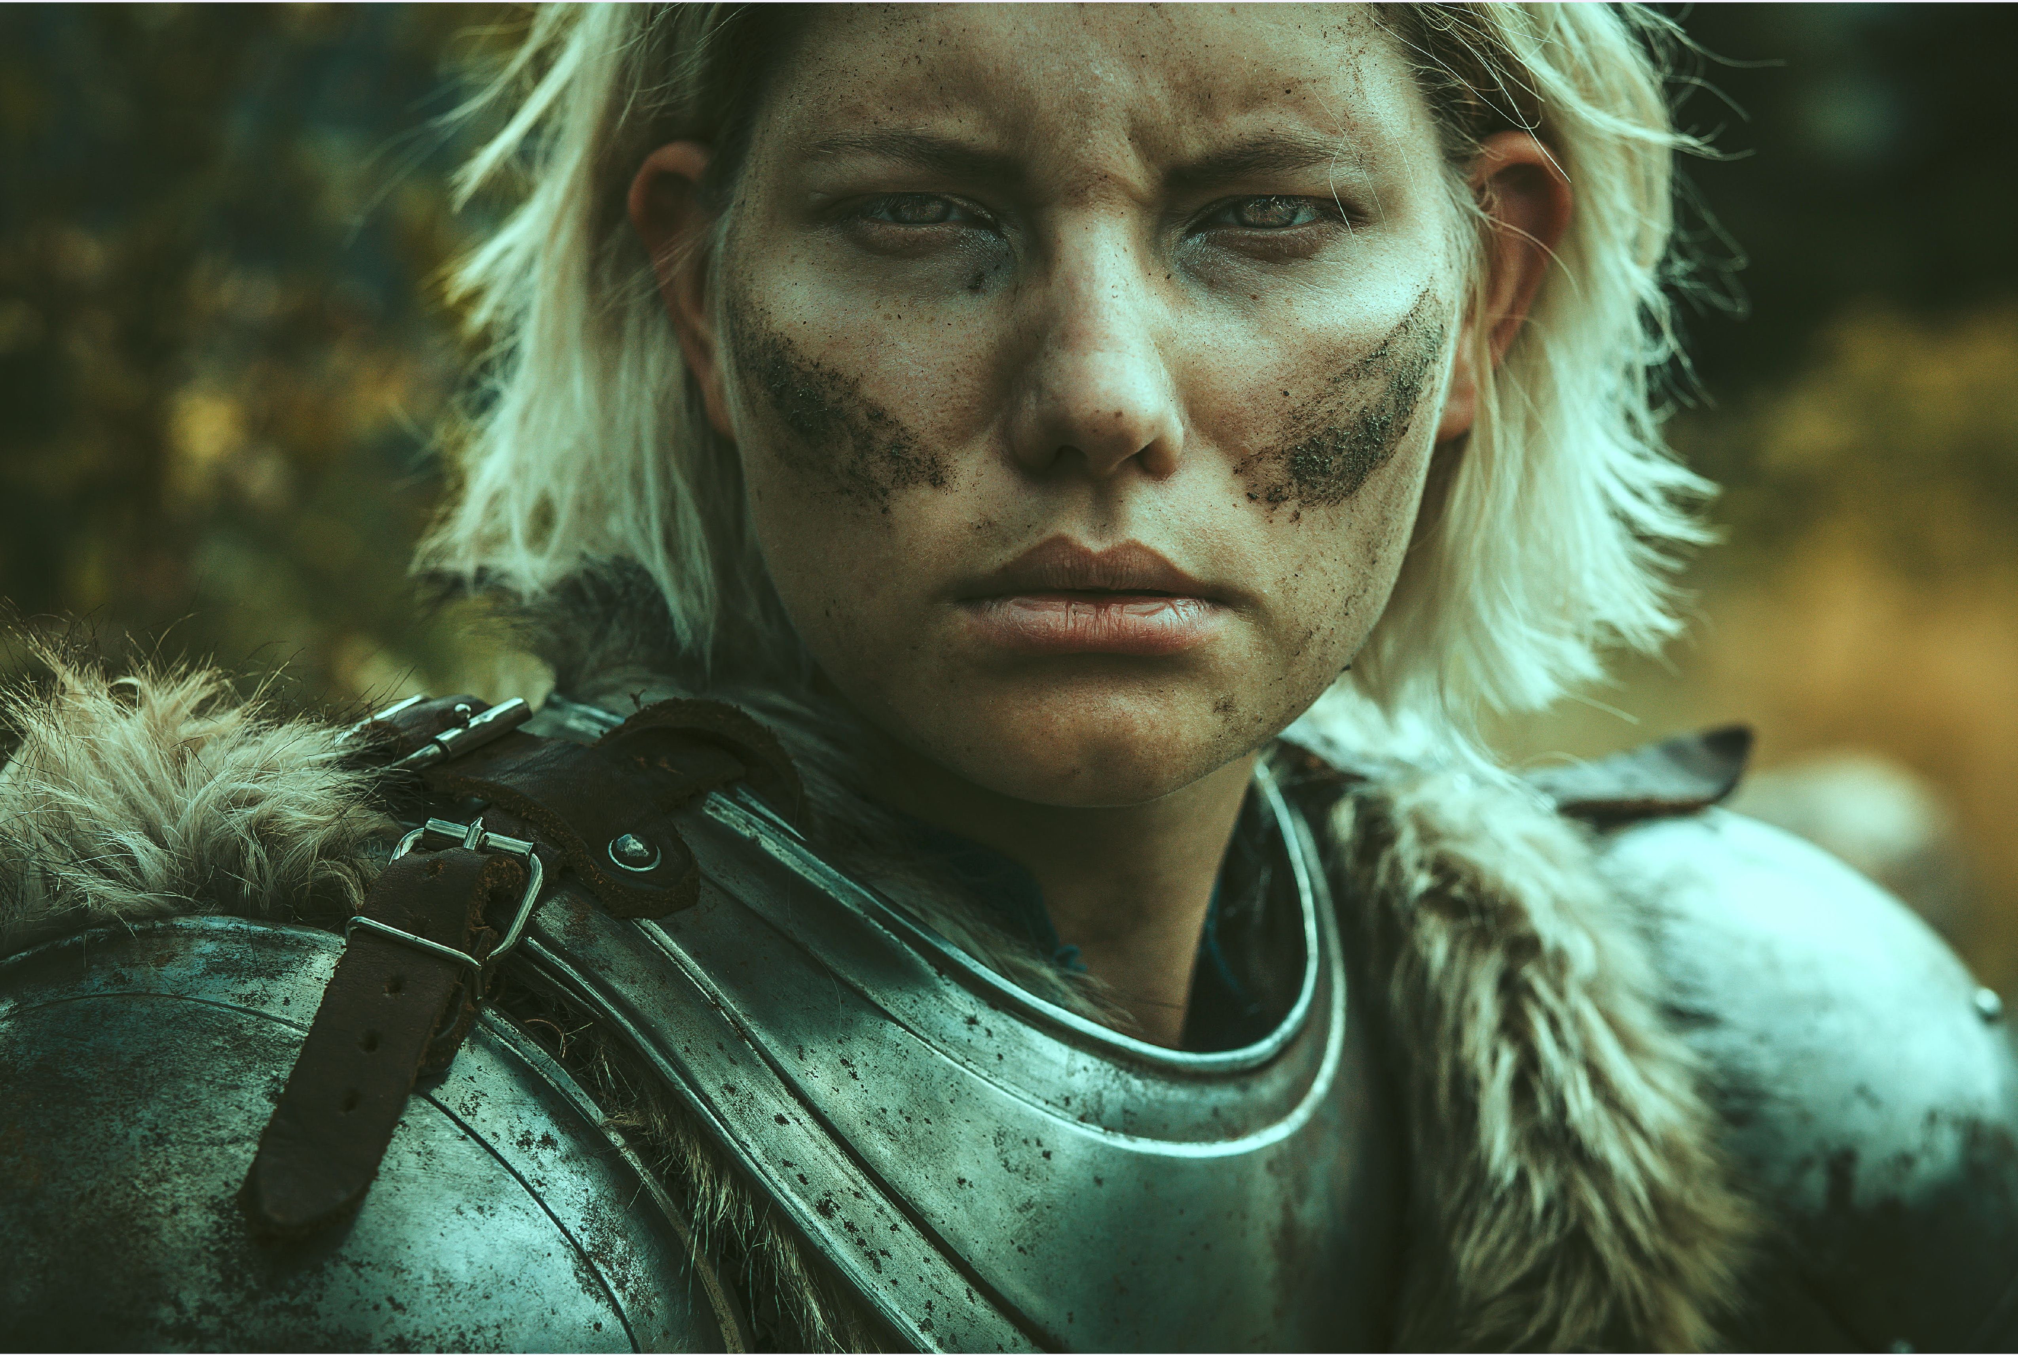

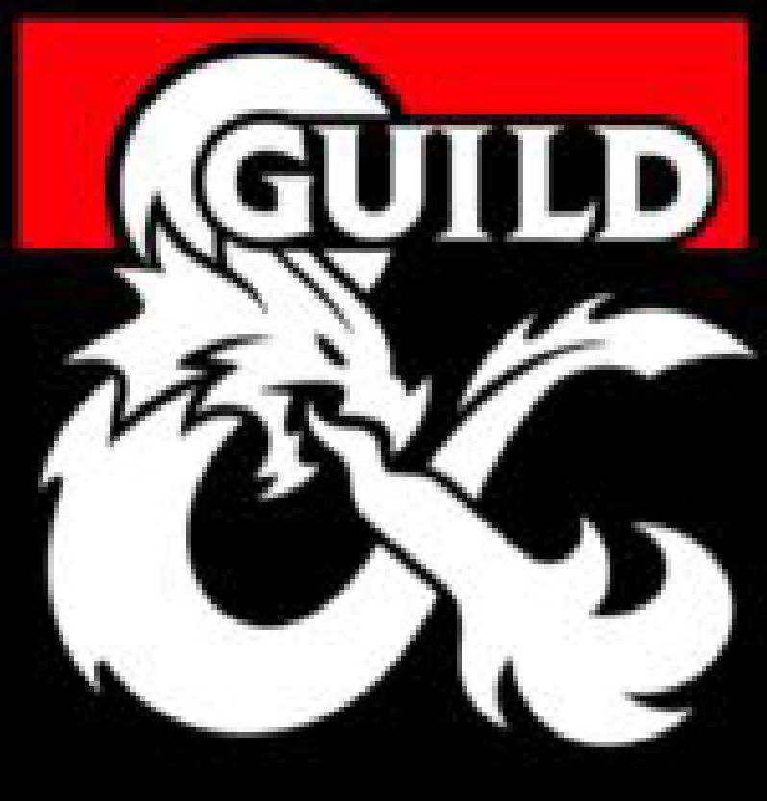

Nobles of Cormyr

Eye on Cormyr #2: Nobles of Cormyr

Featuring Cormyr-specific information to supplement the Noble background in the Player**'**s Handbook and the Waterdhavian Noble in the Sword Coast Adventurer**'**s Guide

by

JEREMY E. GRENEMYER

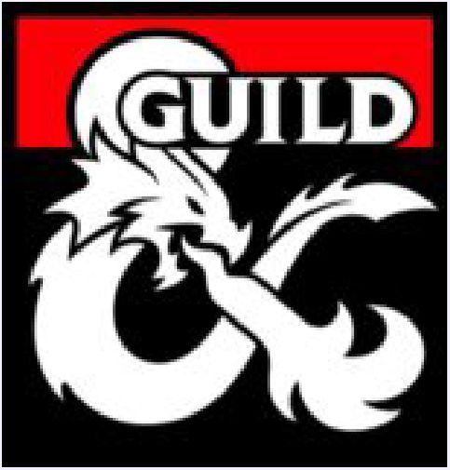

COMMONPLACE PUBLISHING

*A good game starts with a good story.*

Visit [Commonplace Publishing](https://www.facebook.com/commonplacepub/) on Facebook

Designed with [The Homebrewerv](http://homebrewery.naturalcrit.com/). [Imgur](https://imgur.com/). [Adobe Stock](https://stock.adobe.com/images), and Adobe Photoshop

[#CormvrStories](https://twitter.com/search?src=typd&q=%23cormyrstories)

**ON THE COVER: Lady Danathea Rowanmantle**

DUNGEONS & DRAGONS, D&D, Wizards of the Coast, Forgotten Realms, the dragon ampersand, Player’s Handbook, Monster Manual, Dungeon Master’s Guide, D&D Adventurers League, all other Wizards of the Coast product names, and their respective logos are trademarks of Wizards of the Coast in the USA and other countries. All characters and their distinctive likenesses are property of Wizards of the Coast. This material is protected under the copyright laws of the United States of America. Any reproduction or unauthorized use of the material or artwork contained herein is prohibited without the express written permission of Wizards of the Coast.

©2019 Wizards of the Coast LLC, PO Box 707, Renton, WA 98057-0707, USA Manufactured by Hasbro SA, Rue Emile-Boechat 31, 2800 Delemont, CH. Represented by Hasbro Europe, 4 The Square, Stockley Park, Uxbridge, Middlesex, UB11 1ET, UK.

This work contains material that is copyright Wizards of the Coast and/or other authors. Such material is used with permission under the Community Content Agreement for Dungeon Masters Guild

Copyediting by Gabrielle Harbowy

Cover image [© Tana Pechlatova](https://www.instagram.com/photography_pechlatova/?hl=en). Used by permission (9/25/2018). [Map of West-Central Cormyr](https://www.dmsguild.com/product/192660/Cormyr-Region-Maps-WestCentral-Cormyr) by Ross Cody. Artwork ©Jeremy E. Grenemyer.

Some page backgrounds by Jeremy E. Grenemyer. All other artwork and images used under license via Adobe Stock: [© ad hominem](https://stock.adobe.com/contributor/203950581/ad-hominem?load_type=author&prev_url=detail). [© artvme](https://stock.adobe.com/contributor/206072509/artyme?load_type=author&prev_url=detail). [© Вероника Преображено](https://stock.adobe.com/contributor/207513472/%D0%B2%D0%B5%D1%80%D0%BE%D0%BD%D0%B8%D0%BA%D0%B0-%D0%BF%D1%80%D0%B5%D0%BE%D0%B1%D1%80%D0%B0%D0%B6%D0%B5%D0%BD%D1%81?load_type=author&prev_url=detail).

[© Dream-Emotion](https://stock.adobe.com/contributor/200391231/dream-emotion?load_type=author&prev_url=detail). [© diter](https://stock.adobe.com/contributor/200368900/diter). [© grape vein](https://stock.adobe.com/contributor/201731834/grape-vein?load_type=author&prev_url=detail). [© ian stopka](https://stock.adobe.com/Member/LicenseHistory?date_order=desc&current_tab=tab-purchases&history_page=16). [© Master1305](https://stock.adobe.com/contributor/205079253/master1305?load_type=author&prev_url=detail). [© valeo5](https://stock.adobe.com/contributor/203728996/valeo5?load_type=author&prev_url=detail)

All other original material in this work is © 2015, 2016, 2017, 2018, 2019 Commonplace Publishing and published under the Community Content Agreement for Dungeon Masters Guild

Volume 1, Article 2 JULY 2019

**Without the contributions to Cormyr by the following authors, game designers, and Realmslore enthusiasts this article would not have been possible:**

Grant Christie, Brian Cortijo, Jerry Davis, Erik Scott de Bie, Erin M. Evans, Ed Greenwood, Jeff Grubb, Brian R. James, George Krashos, and Kate Novak.

**Special thanks to Brian Cortijo for lending his encyclopedic knowledge of Cormyr to this project.**

Nobles of Cormyr

he Noble background found in the *Player's Handbook* (p.135-136) and the Waterdhavian № 11 Noble found in the *Sword Coast Adventurer's* > j *Guide* (p.154) are excellent resources for *J* creating characters of noble blood. This article expands your character creation options by 1 providing information about Cormyr's many noble families.

This article is loosely organized around the questions posed to you in the Noble background description, which you and your Dungeon Master are asked to consider during the character creation process. Two additional variants, the Exile and Lost Heir, are included for your consideration.

Nothing in this article overwrites the information in the *Player's Handbook* or the *Sword Coast Adventurer's Guide,* just as nothing in this article overrules your sense of creativity and that of your Dungeon Master. **Use what you want and ignore the rest.**

Have fun!:)

**CORMYREAN NOBLE**

One of your ancestors performed a great deed of service to the Forest Kingdom. This deed earned special recognition from the ruling Obarskyr of the time, for which your ancestor was granted a noble title, along with the responsibilities and perks such a title affords.

When you came of age, you bent the knee within the Chamber of the Purple Dragon as Cormyr's ruling monarch looked down upon you from the Dragon Throne. You swore your loyalty and received your title.

As a Cormyrean of noble blood you have inherited the legacy of your noble house, a duty to Cormyr's monarch and the Crown, and above all a responsibility to defend Cormyr from its enemies. You are obliged to seek out and eliminate dangers that imperil the Forest Kingdom, even if it means sacrificing your life to do so.

Select your noble surname from the following list of noble families.

Noble Families of Cormyr

A: Alamber, Alsevir, Ambershields, Ambrival, Ambruar, Andolphyn, Arcantlet, Aris, Armeld, Aunkspear, Axehand

B: Barelder, Battlebar, Battlestar, Belorgan, Bhela, Blacksilver, Blackwinter, Blester, Bleyshar, Bogbrook, Bracegauntlet, Braelbane, Braerwinter, Briarbroke, Bryarn, Buckfast, Burnig

C: Calantar, Cordallar, Cormaeril, Crakehall, Creth, Crownrood, Crownsilver

D: Dagohnlar, Darendall, Darstan, Dathcloake, Dauntinghorn, Dawningdown; Dawninghunt, Dawntard, Delcastle, Delzuld, Domrith, Downshield, Dracohorn, Dragonwood

E: Ebonhawk, Eldroon, Emmarask, Erdusking, Evenhand, Eveningspire, Everet

F: Farrowbrace, Flintfeather, Foulweather

G: Gauntweather, Goldfeather, Greatgaunt, Greenmantle, Gyrlond

Noble Families (continued)

H: Haelbroke, Haldoneir, Halvaeron, Handragon, Harcourt, Hardcastle, Hardivyper, Harefollow, Hargryphon, Harkuldragon, Hartalan, Hartel, Harvendur, Hawklin, Helderstone, Helmstone, Helstallion, Hethemer, Hiloar, Hlombur, Horncastle, Hornhold, Huntcrown, Huntingdown, Huntinglance, Huntinghorn, Huntsilver, Hyraken

I: Illance, Imbranneth, Immerdusk, Indesm, Indimber, Indulshields, Ironcastle

J: Jarthoon

K: Kallowsar, Keskrel, Kessemer, Kraliqh

L: Longbrooke, Longflail, Lornsar, Loround

M: Mallowbridge, Mantlepard, Marliir, Melvir, Misrim, Mistwind, Monthor, Morler, Mournsoul, Mountwyrm, Muscalian

N: Naerinth

O: Oldbridle, Ormblade, Orthwood

P: Paertrover, Phaulkon, Pursenose

R: Rallyhorn, Ravenhill, Ravensgar, Rayburton, Redbow, Ridinghound, Roaringhorn, Rowanmantle

S: Sarlival, Sauvrurn, Scatterstars, Scoril, Silverhorn, Silversword, Skatterhawk, Sorndrake, Sornstern, Spurbright, Staghunt, Staglar, Steelaens, Stonecastle, Stonestable, Stonetower, Stormserpent, Summerstar, Summertree, Sundever

T: Talcontin, Tammarast, Tantorn, Tathcrown, Tavernant, Thalthallow, Thandro, Thawnfaer, Thistle, Thornstag, Thorntower, Thundersword, Tolon, Torchmore, Torchtower, Torchwinter, Torith, Truesilver

V: Vaeren, Vaylan

W: Warblade, Wavegallant, Windstag, Wintercoats, Wintersun, Wolfwinter, Wyrvar, Wyvernspur

Y: Yellander

Determine Your Noble Title

As a child you were taught that the Obarskyr family has ruled Cormyr in an unbroken succession of Kings and Queens for nearly fifteen centuries. Only Cormyr's ruling monarch may bestow a noble title.

Noble Titles Ranked Lowest to Highest

|  |  |  |
| --- | --- | --- |
| d8 | Title | Hereditary? |
| 1 | Knight/Lady Knight | No |
| 2-3 | Baronet/Baronetess | Yes |
| 4-5 | Baron/Baroness | Yes |
| 6-7 | Viscount/Viscountess | Yes |
| 8 | Earl/Countess | Yes |

**NOBLES OF CORMYR**

Knight

The title of Knight is granted for brave action in support or defense of Cormyr. It is not a title that can be passed on, nor inherited. You may still choose the Noble Variant: Knighthood feature (PHB p.136). Your title is Baronet/Baronetess.

Baronet/Baronetess

Noble families that have survived a century or more contain numerous members of this rank. This is the lowest of the hereditary noble titles.

Baron/Baroness

The second most numerous title held among Cormyrean nobility. As Lord Lhalaundrovam Keskrel of Marsember described it to his son, Irlake: "The title rolls off the tongue nicely, but you will have to work to make it mean something."

Viscount/Viscountess

’A title worth having, if you have nothing else," as the long ago exiled noble Ryndala Merendil once said. The heads of many established noble families are Viscounts/Viscountesses.

Earl/Countess

The usage of "count" has died out in Cormyr, in favor of "earl" Oldblood noble families count several earls and countesses among their ranks.

What Powers Do Nobles Have?

* A noble is not required to tie a peace string around their sword (to keep it from being drawn swiftly in anger).
* A noble may detain lawbreakers on their family lands.
* A noble may arrest someone for breaking Crown law if the crime occurs in the noble’s presence.
* A noble must turn lawbreakers over to the Crown for trial and punishment.
* A noble may temporarily hire mercenaries.
* A noble may build and occupy fortified residences.

What Powers Do Nobles NOT Have?

* A noble may not swear fealty to anyone besides Cormyr’s ruling monarch.
* A noble may not accept oaths of fealty from anyone else— even another noble.
* A noble may not punish or try someone for their crimes.
* A noble may not raise up a private army loyal to them alone.

Variant Noble: Exile

You are a member of a noble family that has been exiled from Cormyr. Select an exiled family from the following list.

Bleth, Garthhawk, Merendil, Orgaunt

If you wish to be an Exile, choose the Retainers feature (PHB p.136) instead of the Position of Privilege feature. The number of retainers you have is two, not three, and each retainer is loyal to you and your exiled family. Your retainers each maintain a simple, minor property with a hidden space to accommodate you if your true identity is ever discovered while you are adventuring in Cormyr.

You may substitute one of your Skill Proficiencies for Deception. Your Tool Proficiency is disguise kit. Your equipment includes a set of fine clothes, a disguise kit, a stolen signet ring belonging to another noble house, and a purse containing 20gp.

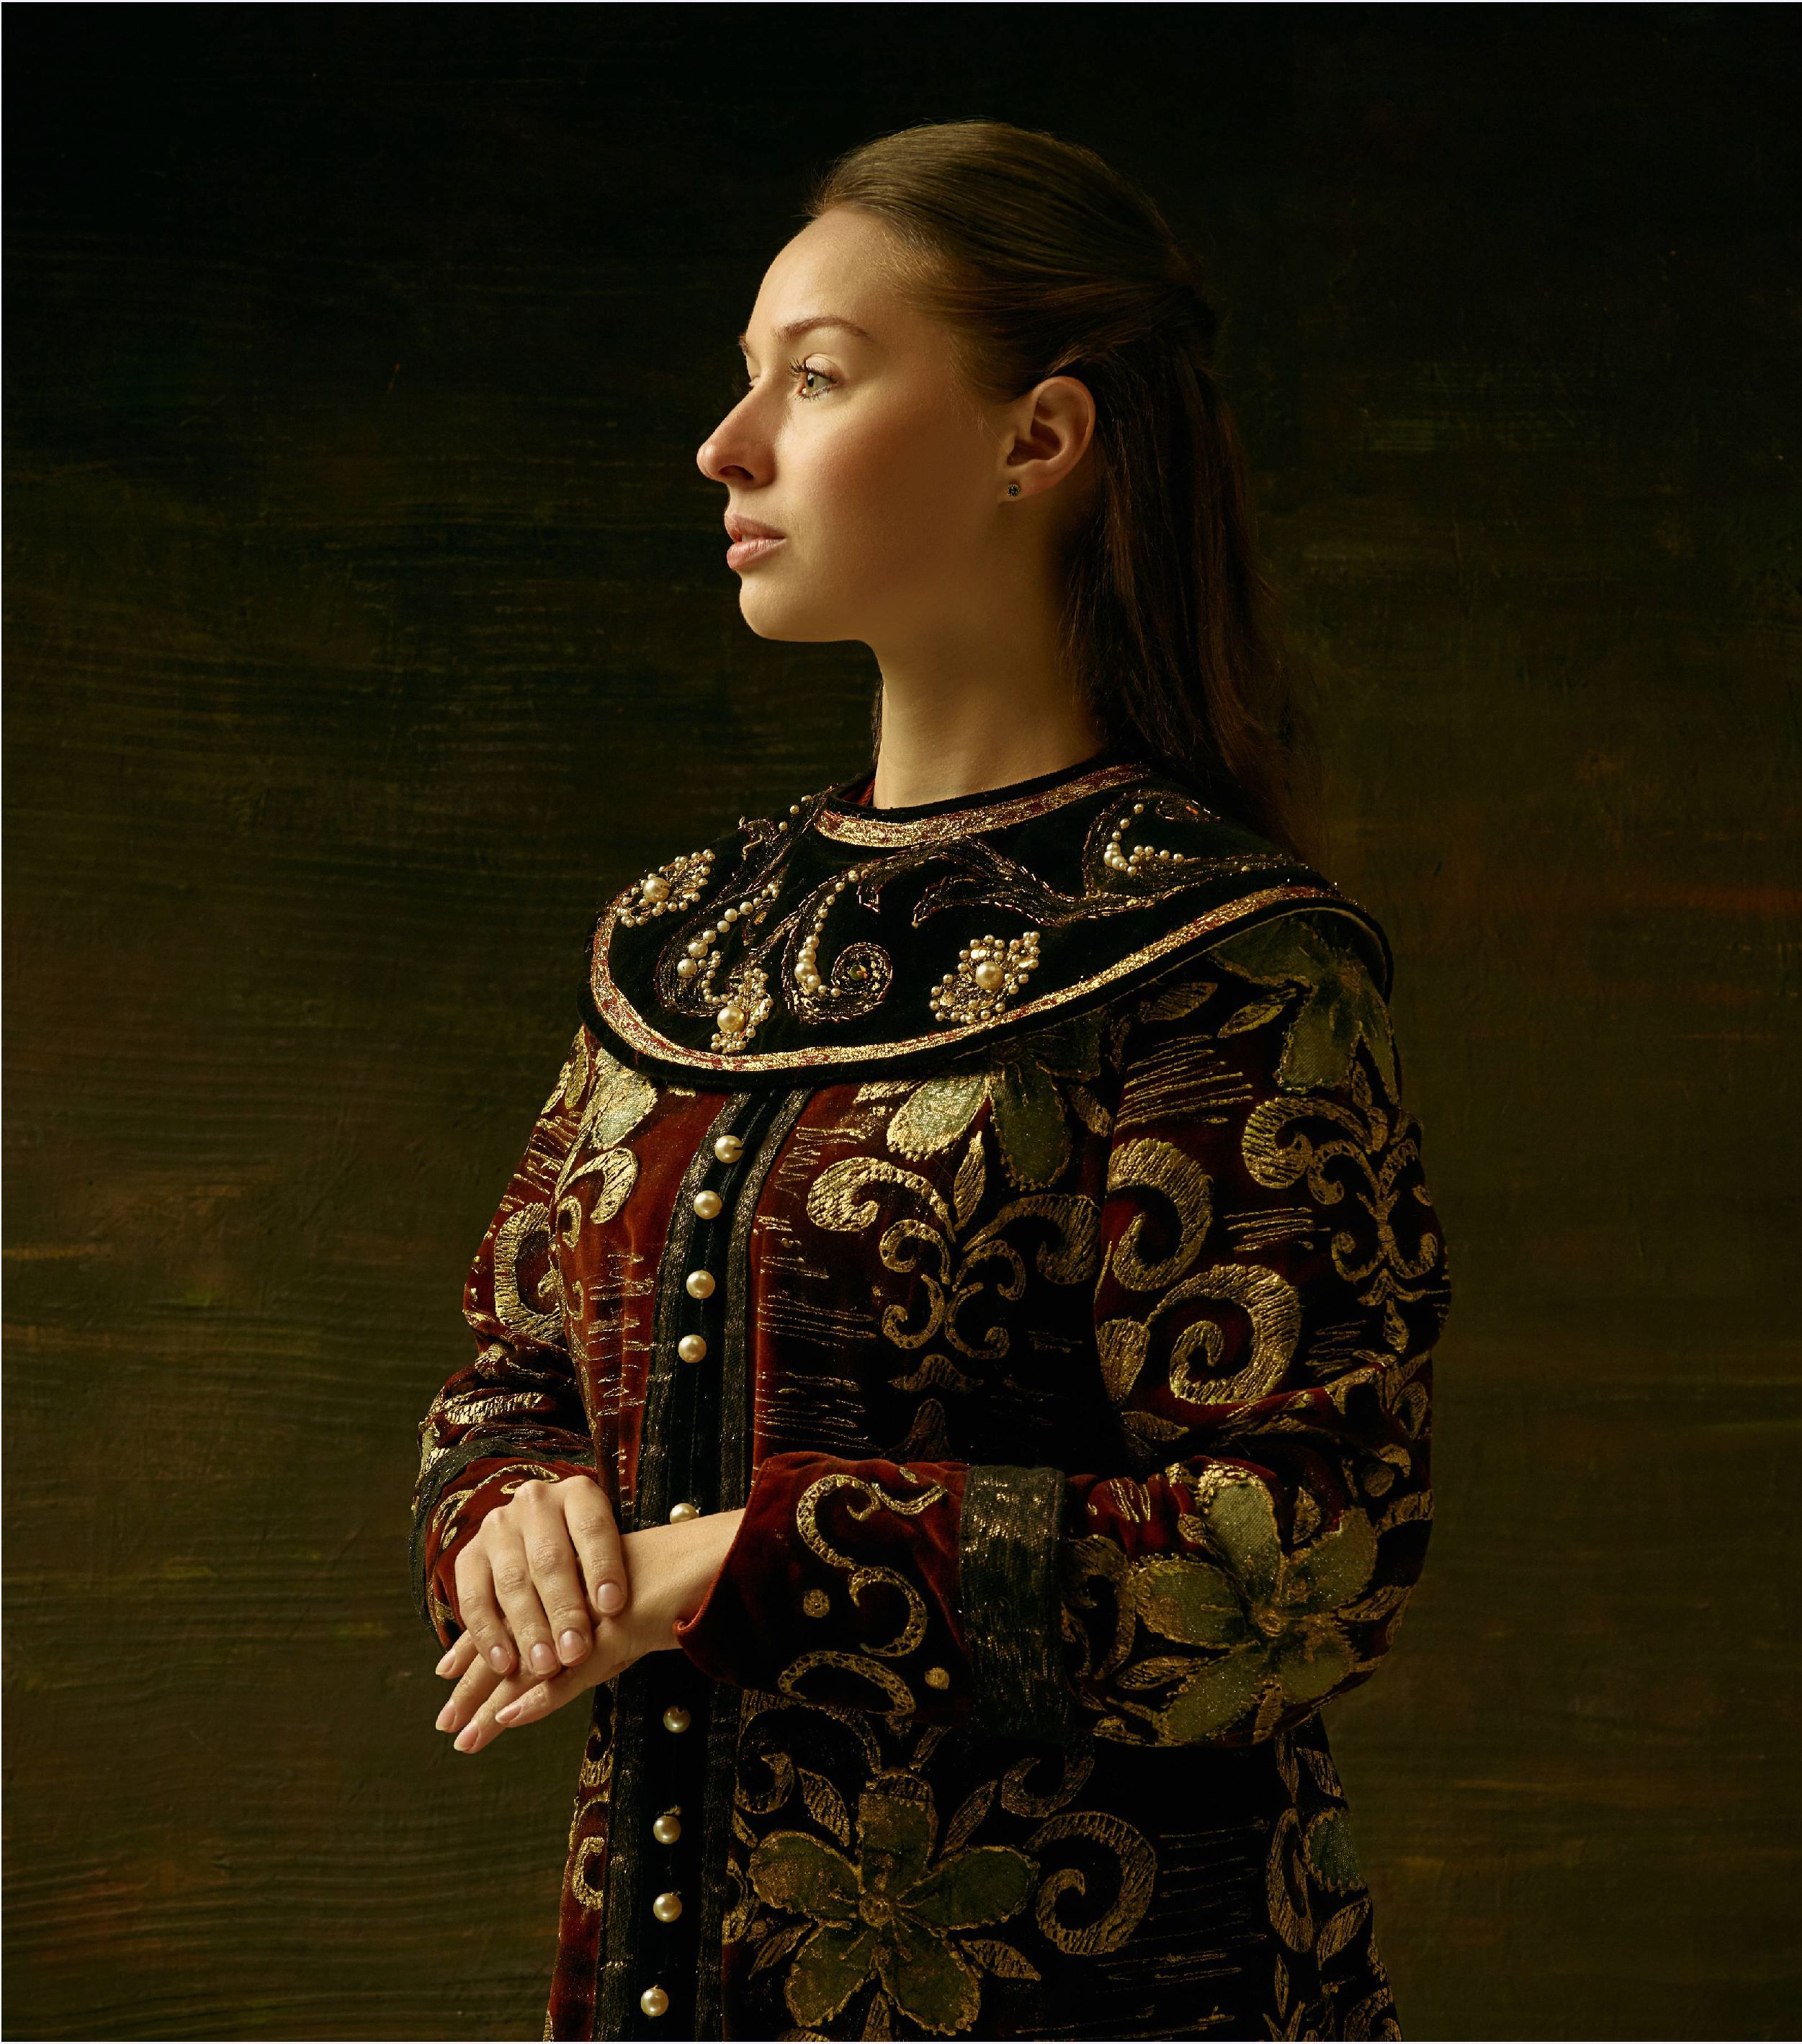

Variant Noble: Lost Heir

Your lineage includes one ancestor that belonged to a Cormyrean noble family. Choose option 1 or 2:

1. The noble family to which your ancestor belonged is dying out. Select a family from the list on page 1. Including you, there are only five family members left. Roll ld4 to determine your place in the line of succession.
2. The noble family your ancestor belonged to is extinct. Select a noble family from the following list.

Auntiver, Aurubaen, Bracebolt, Dheolur, Dragonarl, Drauthglass, Hornshield, Janthrin, Kirinar, Narboot, Tulwood, Turcassan, Ulmair

If you wish to be a Lost Heir, you must choose the Retainers feature. Your retainers are distantly related to the servants that once served the noble family you are related to.

Your equipment includes a scroll case, documents detailing your lineage, a crown of rank that belonged to your noble ancestor (a circlet made of steel with two up-thrust spires, on which ornaments have been affixed that denote acts of service to the Crown), a set of traveler’s clothes and a pouch containing 15 gp.

**ABOVE: LADY CHAMRILLIMMERDUSK**

What Is Your Birth Order?

Where you stand in relation to the head of your House helps to determine the future your family has planned for you. If you are the head of House, then your relatives and your house servants will have to carry the burden of your responsibilities while you travel in search of adventure.

d8 The Line Of Succession:

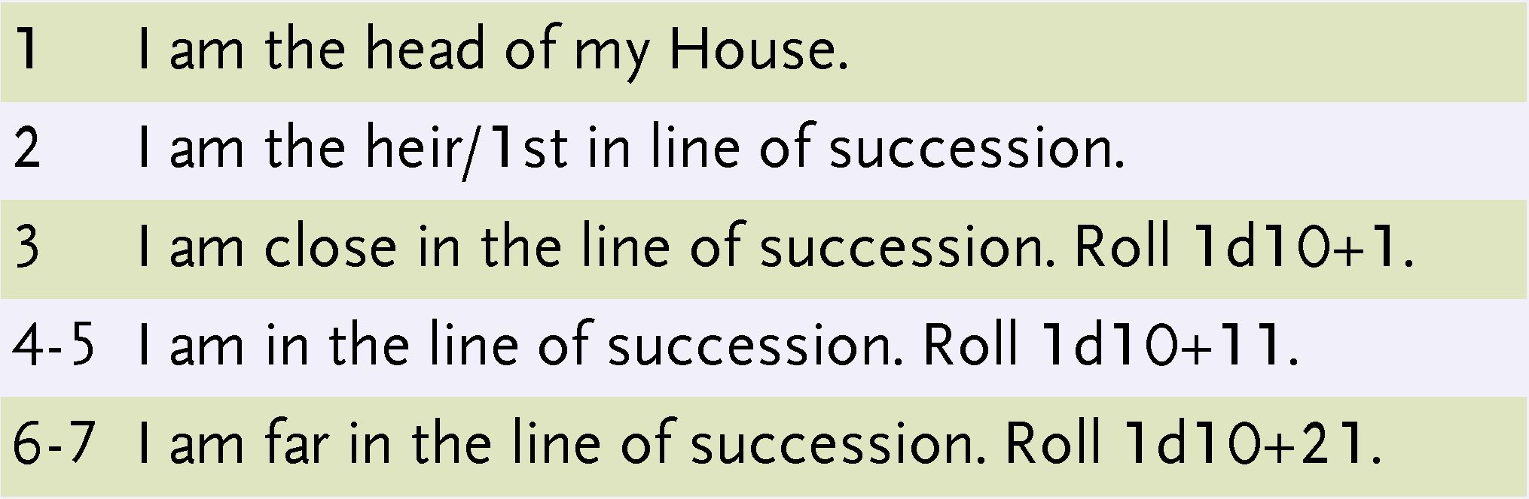

8 Short of a plague I will never be head of House.

What Does Your Family Think of You?

Cormyrean nobles have been explorers, adventurers, and heroes of the Forest Kingdom. You’ve heard the stories of the exploits of your noble House’s founder again and again. They have gained renown and improved their family reputation at Court through their exploits.

But some noble families look unkindly on the idea of adventuring. Others prize loyalty to one’s house over bravado and heroism. A few have quietly arranged ’’accidents’’ to expunge adventuring family members from their houses.

d8 They See You As:

1. An upstanding noble. You are expected to uphold the honor of your house and to not cause harm to your family's reputation on your adventures.
2. Following the example of Cormyr's monarchs, who explored Cormyr while in disguise to see the land and interact with its people. You are expected to hide your true identity and take on a pseudonym.
3. A wildcard. You could bring much needed coin to your family's coffers. You might elevate your family's reputation with your brave deeds. Or you might fail miserably. Time will tell.
4. Better off gone. The family and its interests are much easier to manage in your absence. Good luck.
5. An embarrassment. The sooner you return to the fold, the sooner the scandal caused by your outrageous behavior will end.
6. A wastrel. Your decision to become an adventurer has weakened the family. They may yet decide to return you home by force so that you can take your place and do the work you were raised to do.
7. A liability. If you run afoul of Crown law, your family does not have the influence at Court to defend you. If you are kidnapped for ransom, your family has no spare coin to pay it. If you offend another House, your family will not survive the treachery that may follow.
8. Headed to your grave. Your family is certain you are doomed. Worse, some of your family members would be happy to know you are gone. If you survive too long, they might try to hasten your demise and that of your adventuring companions.



**LADY ESCAME ROARINGHORN AND LORD ANDRAMAGARUS TRUESILVER POSE FOR A PORTRAIT IN THE ROYAL GARDENS ON THE EVE OF THEIR WEDDING IN SUZAIL**

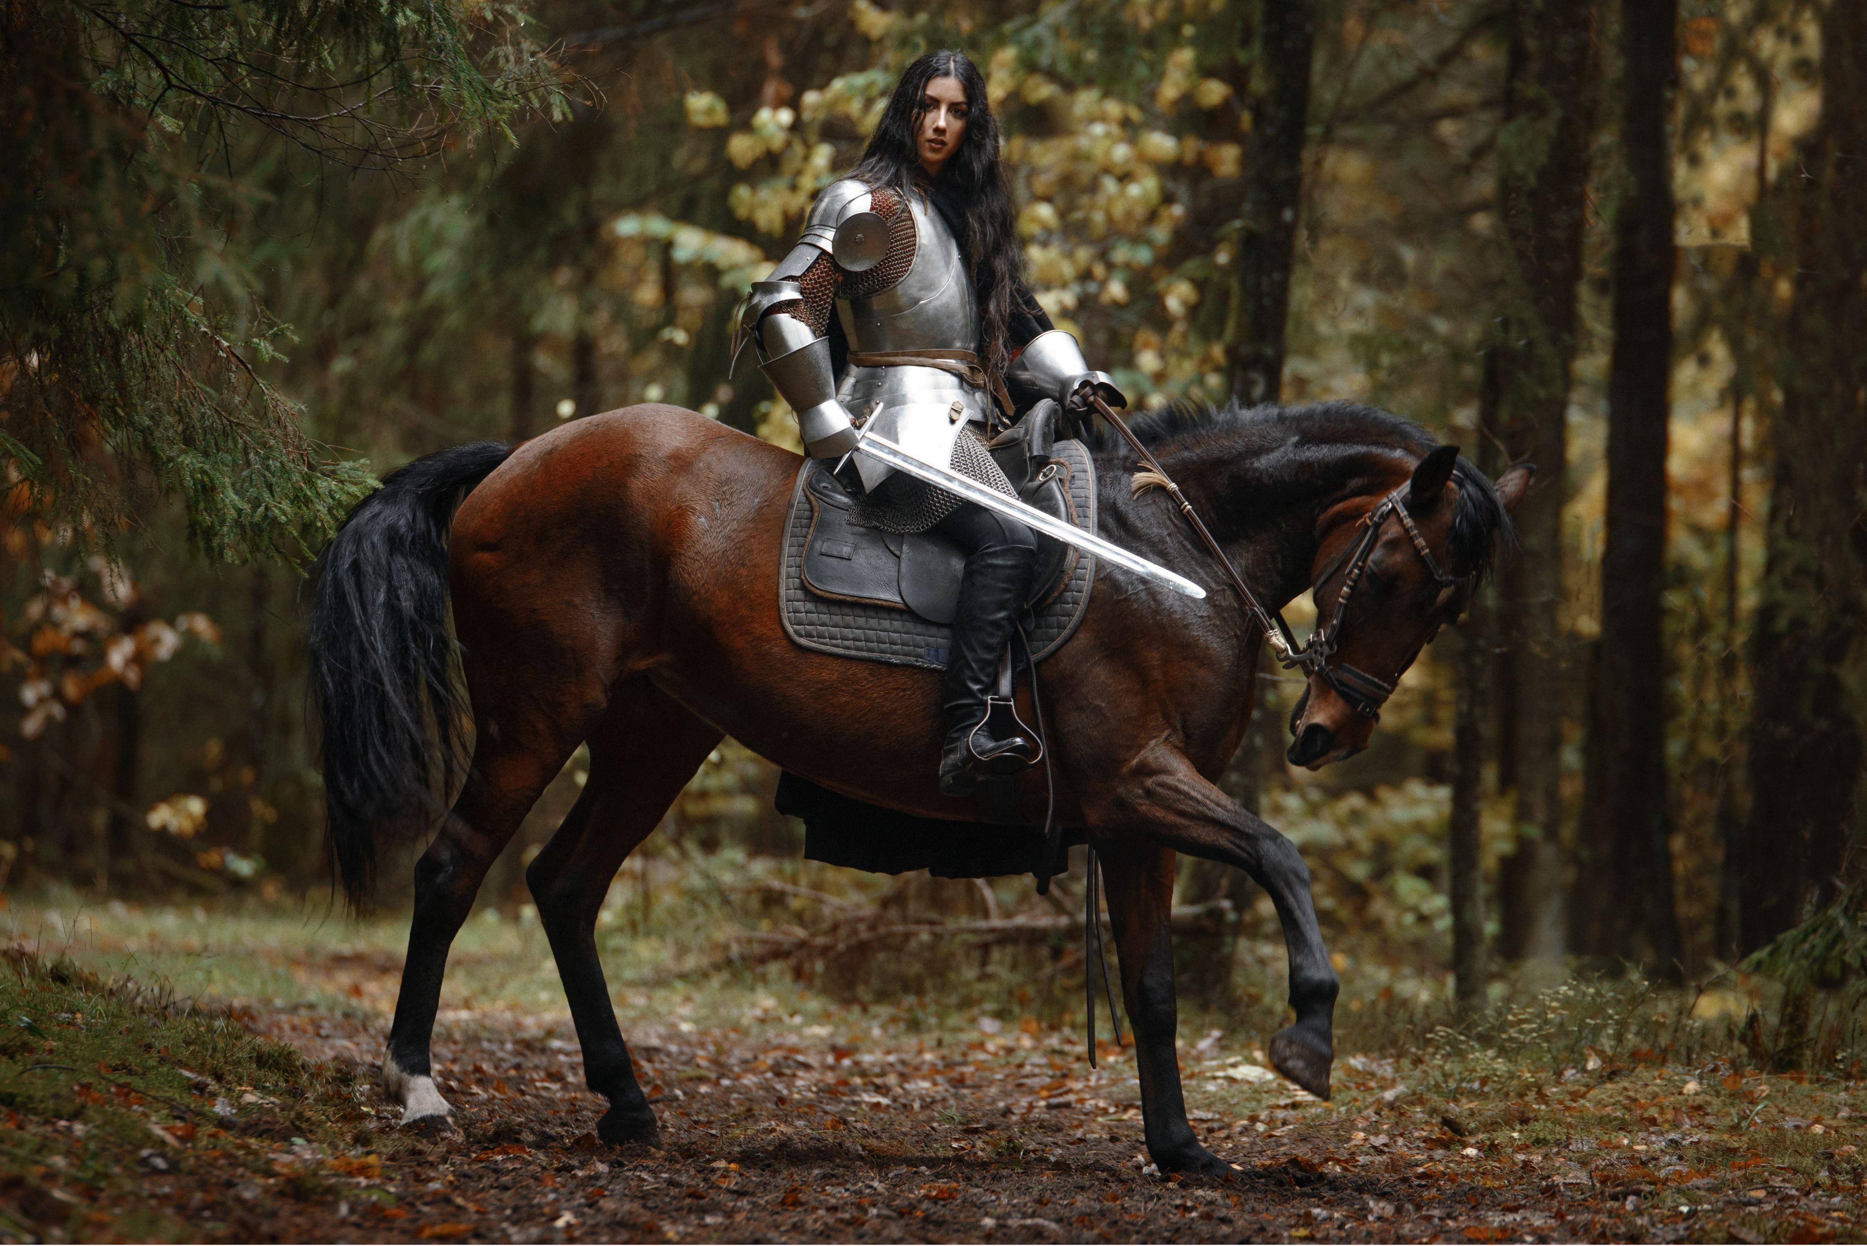

Matters of Family

Roll on the following tables to determine your family’s age, size, reputation, and the status of its wealth.

d8 How Old Is Your Family?

1. 2 New. Less than a century old.
2. 3 Young. One to two centuries old.

4-6 Established. Three to five centuries old.

1. Old. Six to ten centuries old.
2. Oldblood. Eleven to fourteen centuries old.

|  |  |
| --- | --- |
| d8 | How Large Is Your Family? |
| 1 | 1 member: you. |
| 2-3 | 10 members or fewer. |
| 4-5 | 11 to 2 5 members. |
| 6-7 | 26 to 7 5 members. |
| 8 | You have lost count. (76+) |

If your rolls are contradictory (e.g., you determine you are 27th in line of succession, but you have only 10 or fewer family members), roll again or select results that make logical sense.

d8 How Fares The Family Fortunes?

1 Penniless. Your family is buried in debt.

2-3 Hanging in there. A bad year could ruin your family. Many Cormyrean merchant families possess more wealth than your family does.

4-5 Doing all right. Your family pays its assigned taxes to the Crown, works hard for its income and outfits itself in clothing appropriate to the nobility. It does not have extra coins for extravagances.

6-7 Modestly wealthy. Your family has a reserve of coin. Family members wear the latest fashions and spend coins on the latest noble fads. Your family dines at restaurants reserved for nobles in Suzail. It owns property in two of Cormyr's three major cities (Suzail and either Arabel or Marsember).

8 Extravagantly wealthy. That your family flaunts its wealth is a matter of course. Your family's holdings are some of the finest in all of Cormyr, including city properties and numerous minor holdings.

Because you are an adventurer your family expects you to find your own way. If you are on good terms with your family, you and your adventuring companions may be allowed a short stay at one of your family’s holdings.

**You must pay for your own living expenses regardless of your family's wealth.**

**ABOVE: LADY RUVELLE KESKREL PATROLS THE HERMIT'S WOODS**

It is not only wealth, but reputation, that determines the sum of your family's power in Cormyr.

How your family conducts its business, the relationships it keeps with powers outside of Cormyr, and how it interacts with commoners, other noble families, the Purple Dragons, and the Wizards of War all factor into your family's reputation at Court and in the mind of Cormyr's ruling monarch.

Because Noble families win victories and suffer setbacks just like everyone else, your family's reputation may change over time. The actions you take while adventuring can have a significant impact on your family reputation, for better or for worse.

d10 What Is Your Family's Reputation At Court?

1. Bad. Your family has a history of revolt against the Crown. Some of your relatives have been exiled. Others have been jailed for years at a time. In Suzail your family are watched closely by agents of the Crown. The head of your House attends Court only when summoned.
2. Obscure. Few Cormyreans know your family exists. Within the Royal Court, in Suzail, it's always something of a surprise when one of your number shows up.
3. 4 Poor. Your family is held in low regard. Your family may have failed to pay its assigned taxes, sold goods of poor quality, made decisions that led to the injury or death of others, or harmed Cormyr's reputation in some way. The presence of your head of House is tolerated at Court.

5-6 Adequate. Your family has done the minimum to keep to your oaths as nobles. Your relatives spend their time pursuing their own interests. Your family has done little to impress anyone at Court.

7-8 Good. Your family has always tried to do more for Cormyr when the opportunity presented itself. Even though your family has failed as often as it has succeeded, the Crown has always made its appreciation known to the head of your House.

1. Excellent. Your family's allegiance to Cormyr is reflected in the actions of its members and your ancestors. Your family attends Court regularly. Its wisest members are sometimes consulted by the Crown on matters of importance.
2. Superior. Your family is as much a fixture at Court as the ruling monarch. Your family's status makes them feared as much as appreciated. The Crown expects your family to use its power wisely.

Family Coat of Arms

Your tutors have instructed you in matters of heraldry. You know that Cormyrean law follows ancient heraldic custom. Thus, no coat of arms granted by the Crown may be identical to another. Check with your DM to confirm the arms you want to create for your house are different than any arms she is planning to use in her campaign.

Servants, guards, and the agents of noble houses sometimes wear badges sewn into their clothing. These are simplified versions of a house's coat of arms. You are familiar with most of the badges worn by such persons in Cormyr.

The Arms of House Huntsilver

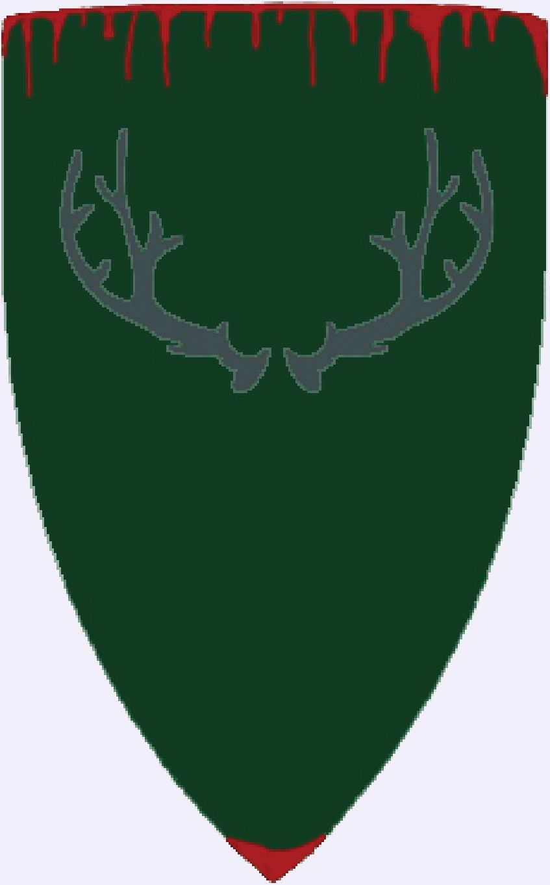

The Arms of House Wavegallant

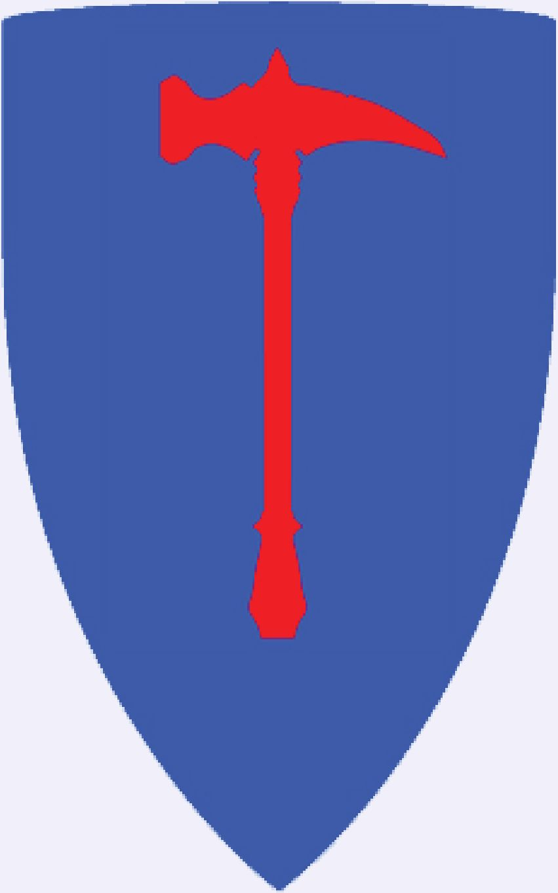

**NOBLES OF CORMYR**

A Place To Call Home

Your family maintains one residence in Cormyr’s capital city, Suzail, and at least one residence somewhere in greater Cormyr.

Create a name for your family’s most important holding outside of Suzail. Keep in mind your results from the How Old Is My Family? and the How Fares My Family’s Fortunes? tables as you write a short description for the residence.

The noble residences in the table below are found on the hexed version of the kingdom-scale map of West-Central Cormyr, which is included at the end of this article. Use the letter/number coordinates to locate them. The sample noble residences are for a Young, Old, and Oldblood house, respectively.

Your family’s remaining holdings are left to your Dungeon Master to reveal during the course of play.

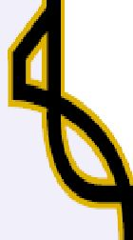

|  |
| --- |
| Sample Noble Residences  Map House Holding Description Location |
| Bleyshar Bleys A country mansion modeled after the homes of old noble houses, the ancestral home of N29  Hard House Bleyshar is built of sturdy wood on a foundation of stone. It is occupied by Shalice  Bleyshar, head of her House. The only other Bleyshar, Shalice's nephew Tantram, remains abroad in Cormyr. The mansion is barely two centuries old. |
| Halaunt Oldspires An old mansion for an old House, Oldspires was built in the days when Cormyrean nobles Q36  had better access to wood than stone, and death lurked in the trees a short walk out the back door. Its two floors are packed with rooms, stairways and secret doors. Rumors of wizard battles within its walls and tales of dark acts performed in its basements have begun to circulate in Cormyr. |
| Paertrover Taverton Part castle, part mansion, part ancestral home and the seat of Paertrover power, Taverton M32  Hall Hall has stood for over a thousand years. Its rooms and halls are resplendent, and tended by  expert servants whose bloodlines are nearly as old as the Paertrover's. Its gardens are the envy of other Houses, and notorious for the murders committed within. Tales of the ghosts of Taverton Hall are told throughout Cormyr. |
| **N-i** |







The names in the lists below are drawn from a long roster of nobles that live (or have lived) in Cormyr. You may use them for inspiration to come up with a first name on your own, or you may select a name from the lists for your character.

If your first name is particularly unwieldy, you may shorten it when introducing yourself for the sake of simplicity. For example, "Laz" instead of ’Alazgrelle" or "Varn" instead of "Sorlthavarn." You may also omit your House name and title when introducing yourself.

If you wish to remain anonymous while adventuring, then you are free to adopt an alias. You might choose to introduce yourself as "Darlock Dreadsword" and not "Viscount Sorlthavarn Bracegauntlet."

Noble First Names: Female

Aglathna, Alaeya, Alanstel, Alathea, Alazgrelle, Andurlatha, Anglorae, Anthra, Asdragarna, Aumbrelle, Baelarra, Beldrara, Chaiass, Dalutheera, Darlethra, Deleira, Embrelle, Harellae, Irenaera, Jalessandra, Janszeene, Jeleskra, Lathdue, Lysandlithe, Maeraedithe, Malaerla, Marantine, Murleeme, Mythandrarra, Narmitra, Nechelseiya, Noenel, Oloebrae, Pheirauze, Raereene, Ravandralla, Relavarra, Resildra, Ruvelle, Sammereza, Shalice, Shamril, Shayna, Taerenthe, Tamglaera, Tamphara, Thornleia, Ulandra, Vaerestra, Yaraela, Zarova

Noble First Names: Male

Adarl, Arclath, Arkanon, Arkeld, Belarkus, Belophar, Broryn, Corgrast, Corlador, Crimmon, Danthalus, Delasko, Deremoz, Elbert, Ergluth, Eskult, Haedro, Harmond, Helaerd, Hornsar, Hundarr, Irlake, Irlin, Jassur, Jeskren, Kaerond, Kathkote, Kreskur, Landrar, Lathlance, Lhalaundrovam, Lyrannus, Maerclorn, Marlin, Melder, Mellast, Mulcaster, Naeryk, Obraerl, Olgarth, Rauligus, Relgadrar, Rordurn, Rorell, Rothgar, Sacrast, Seszgar, Sorlthavarn, Tantram, Tarius, Traevyn

Matters of Appearance

You know that for over fourteen hundred years humans from all over the Realms have come to Cormyr to trade, to explore, and to start new lives. You also know that Cormyr’s Crowned Heads have made nobles out of such people.

Because nobles tend to marry into other Houses and into wealthy merchant families, your ancestry may include bloodlines from the farthest corners of the Realms. As a result, the appearance of the members of your House may differ from that of another House.

The lands bordering the Sea of Fallen Stars use similar terminology to describe skin color. Thus, "cloudskin" is the polite term used by Cormyreans to describe people with visibly white skin; "nightskin" is the polite term for people with visibly black skin; "parchmentskin" is the polite term for people with visibly yellow skin.

• A handful of Cormyrean noble families are nightskin. These include the Houses of Domrith, Hartel, Hethemer, Kallowsar, Lornsar, Sundever, and Torith.

* Mike Schley’s superb Cormyr map is available for free as part of the *Backdrop: Cormyr* article by Brian R. James in Dragon 365, from the Wizards of the Coast website. **[httD://www.wizards.com/files/365__backdroD cormvr.pd](http://www.wizards.com/files/365_backdrop_cormyr.pdf)**
* The free article *Dragon Dreams of the Forest Kingdom: [Death In The Last Drop,](https://www.dmsguild.com/product/265116/Dragon-Dreams-of-the-Forest-Kingdom-Death-In-The-Last-Drop)* [tells a story of Ravance Buckfast,](https://www.dmsguild.com/product/265116/Dragon-Dreams-of-the-Forest-Kingdom-Death-In-The-Last-Drop) an unusually long-lived noble of Cormyr, and his battle with the red dragon Thraxata.

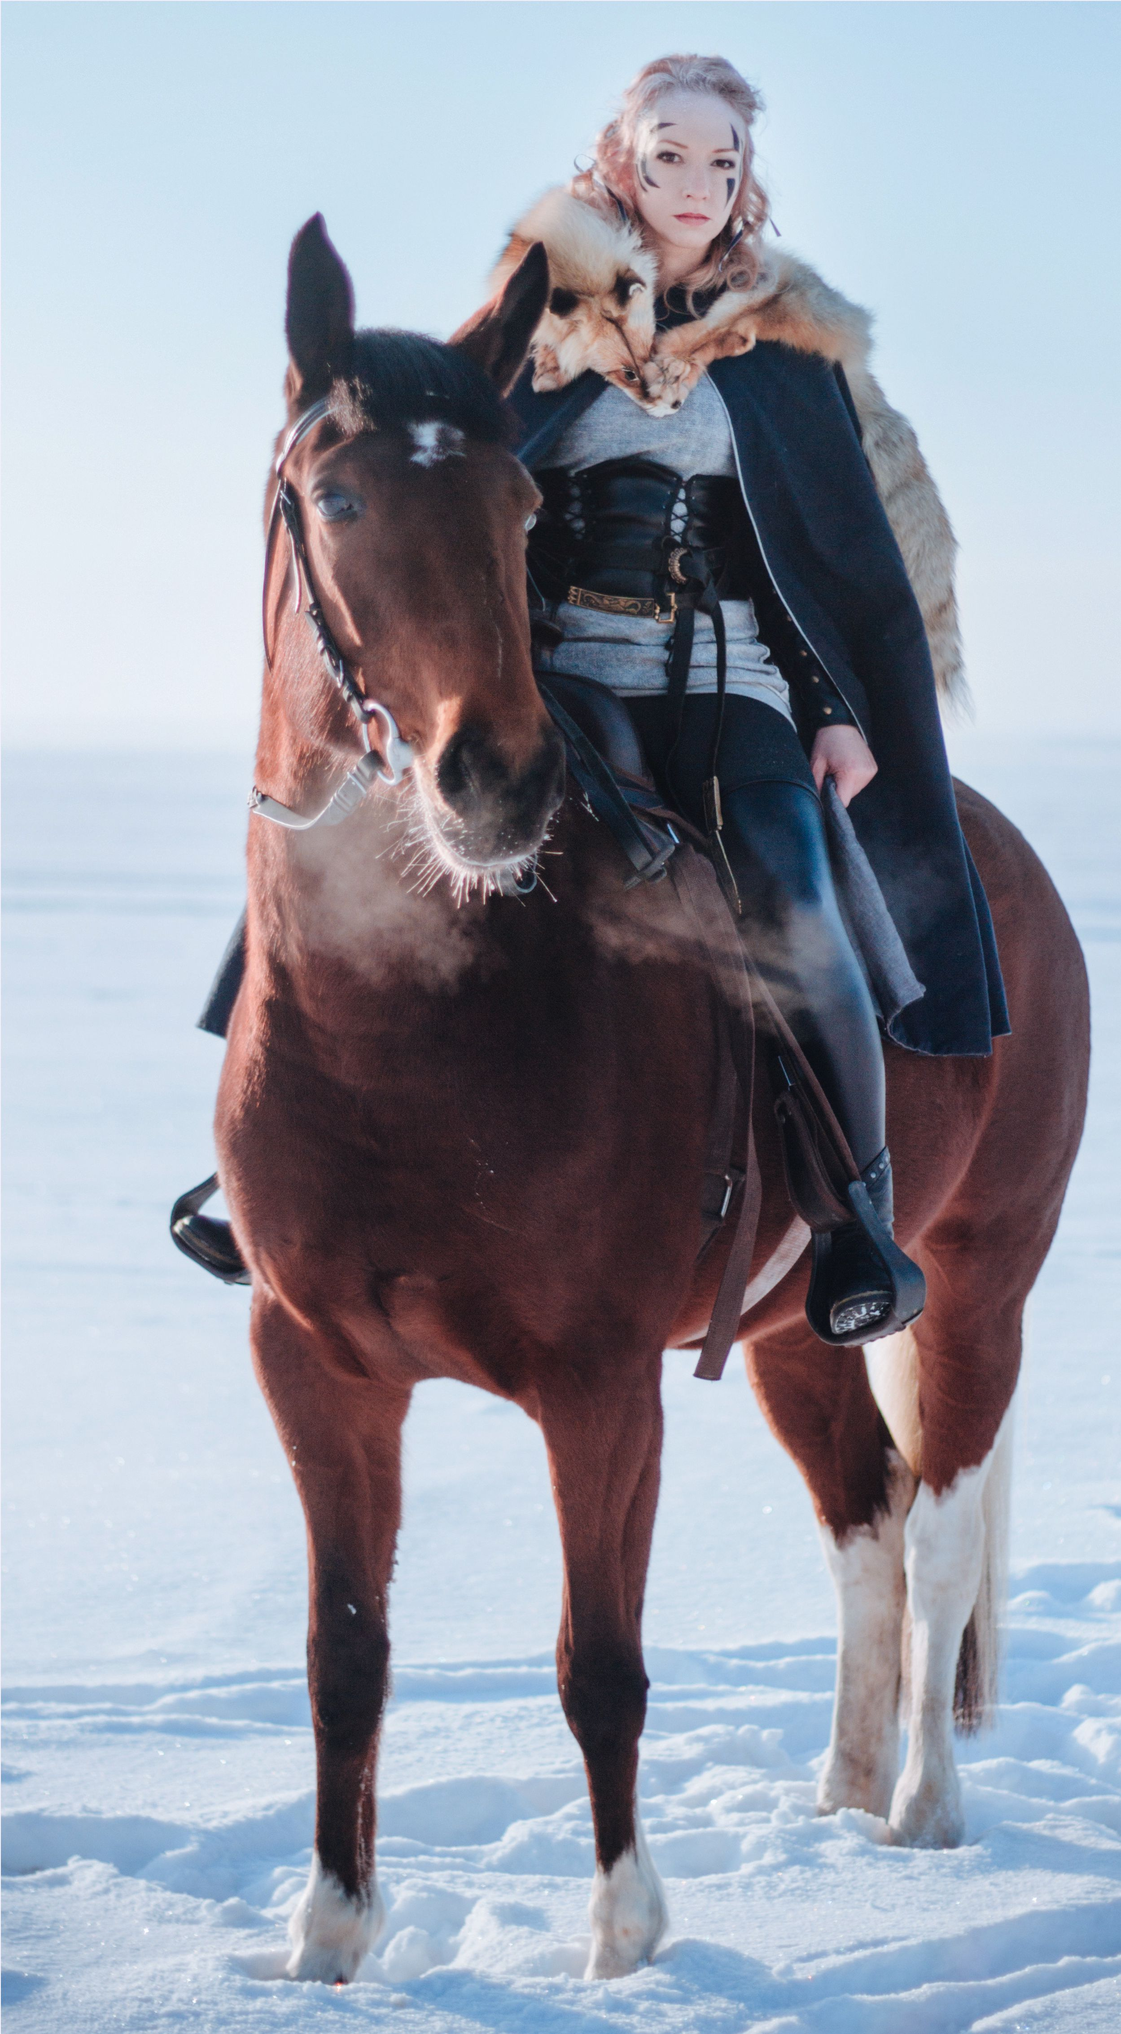

**RIGHT: AMAFREY, LOST HEIR OF HOUSE HALAUNT**



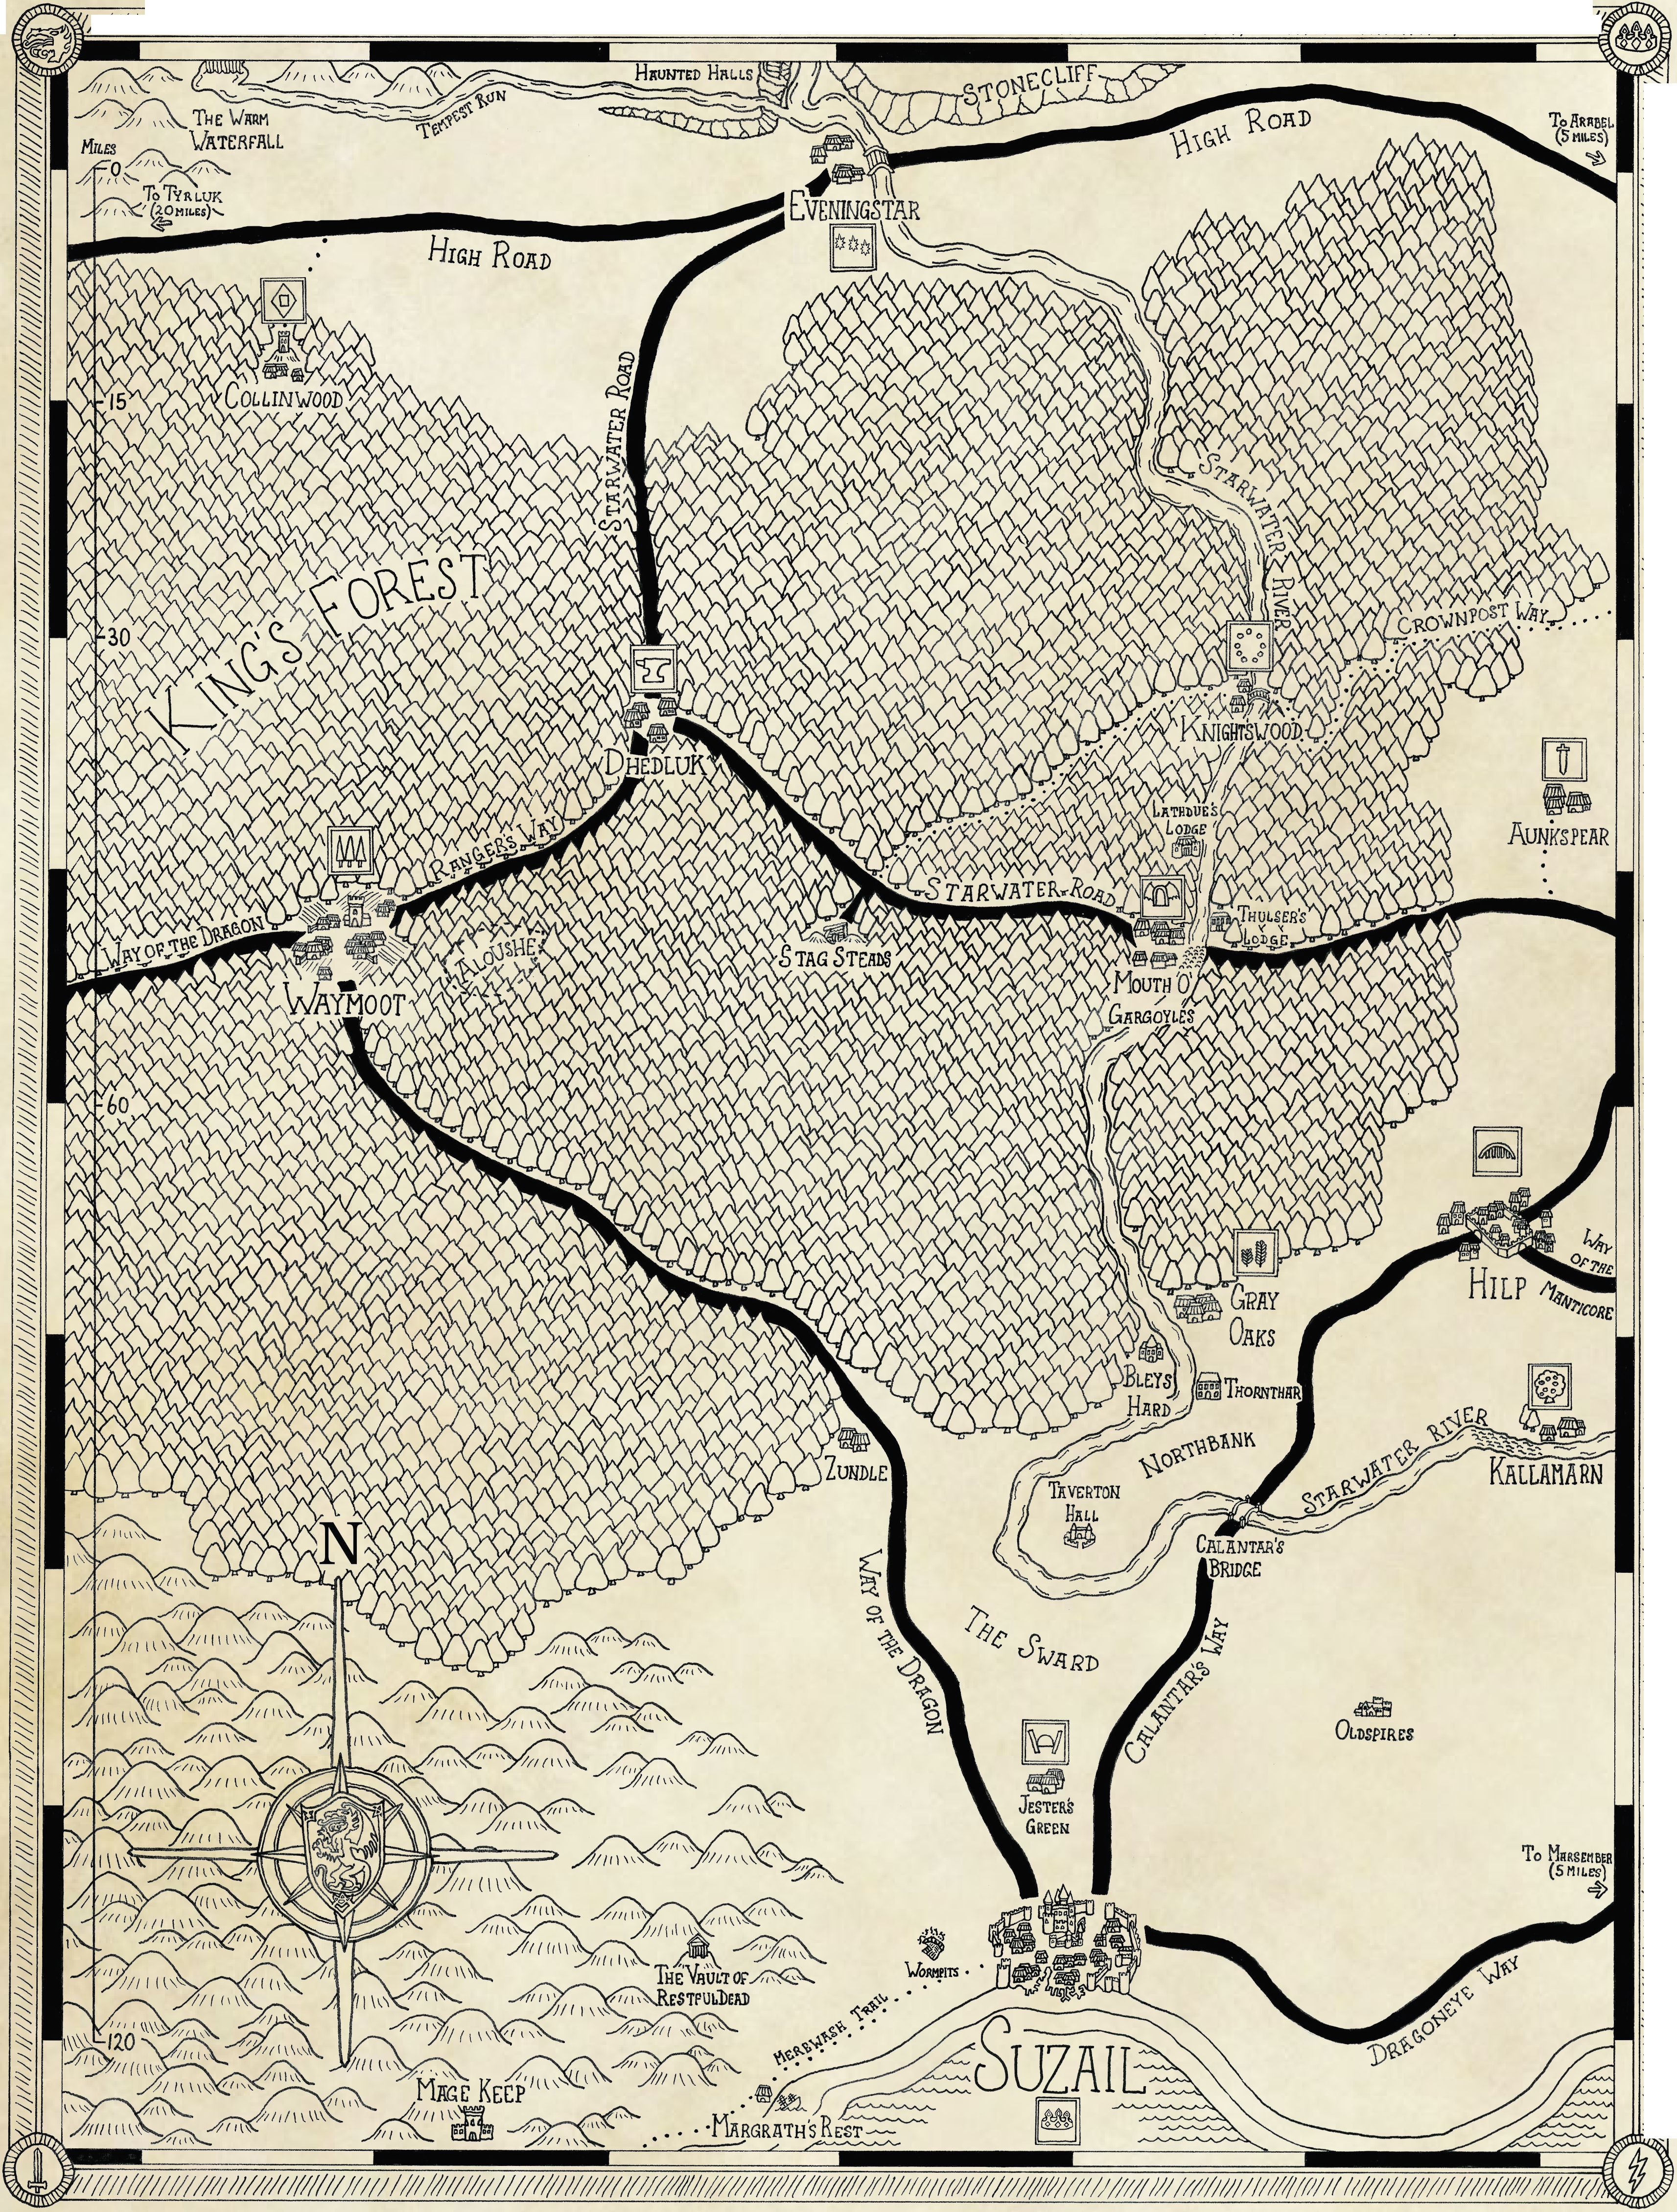

Z////////////W/ ///////////// /////W///7//ZW//y/z//////////W^/W/W /////W/z/zZZ/zZ/7/Z///Z/ZZ/Z/ЖЖ//W/////////////////////////////////////?^

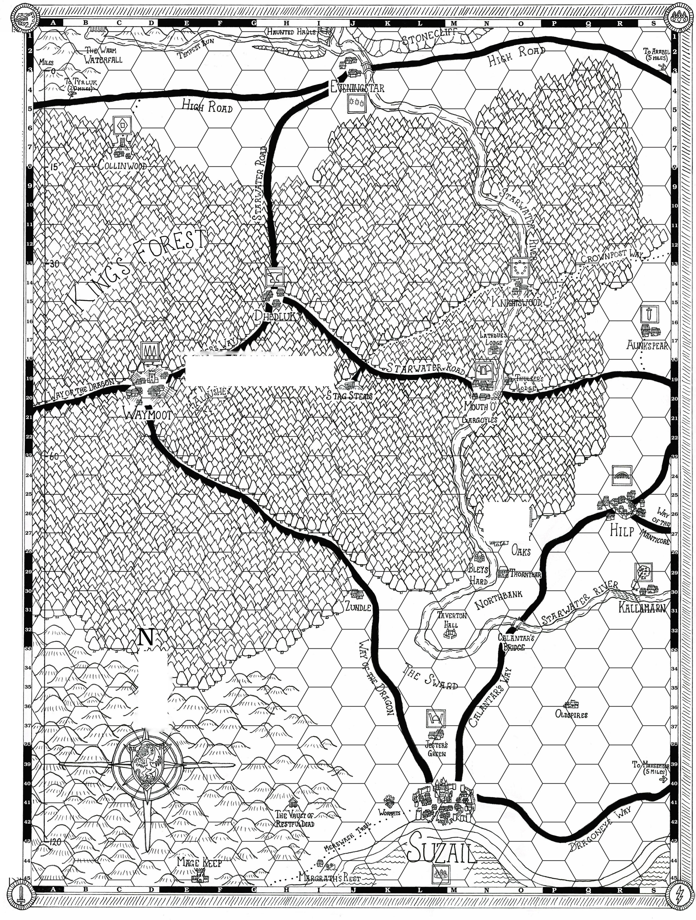

|  |  |  |
| --- | --- | --- |
| **Z\ ' ùlàv^^eW.WVvW л/** |  |  |
|  |  |  |

|  |  |  |  |
| --- | --- | --- | --- |
|  |  |  |  |
|  |
|  | |  |  |
|  |  |
|  | |  | |

|  |  |
| --- | --- |
|  |  |
| \ | X?  1 *'/r* |
| /Zl  *u.* | і/иЛд, U^ZTl) |